Postal Services in Northern Ireland in 2022
Key findings of the Communications Consumer Panel’s research

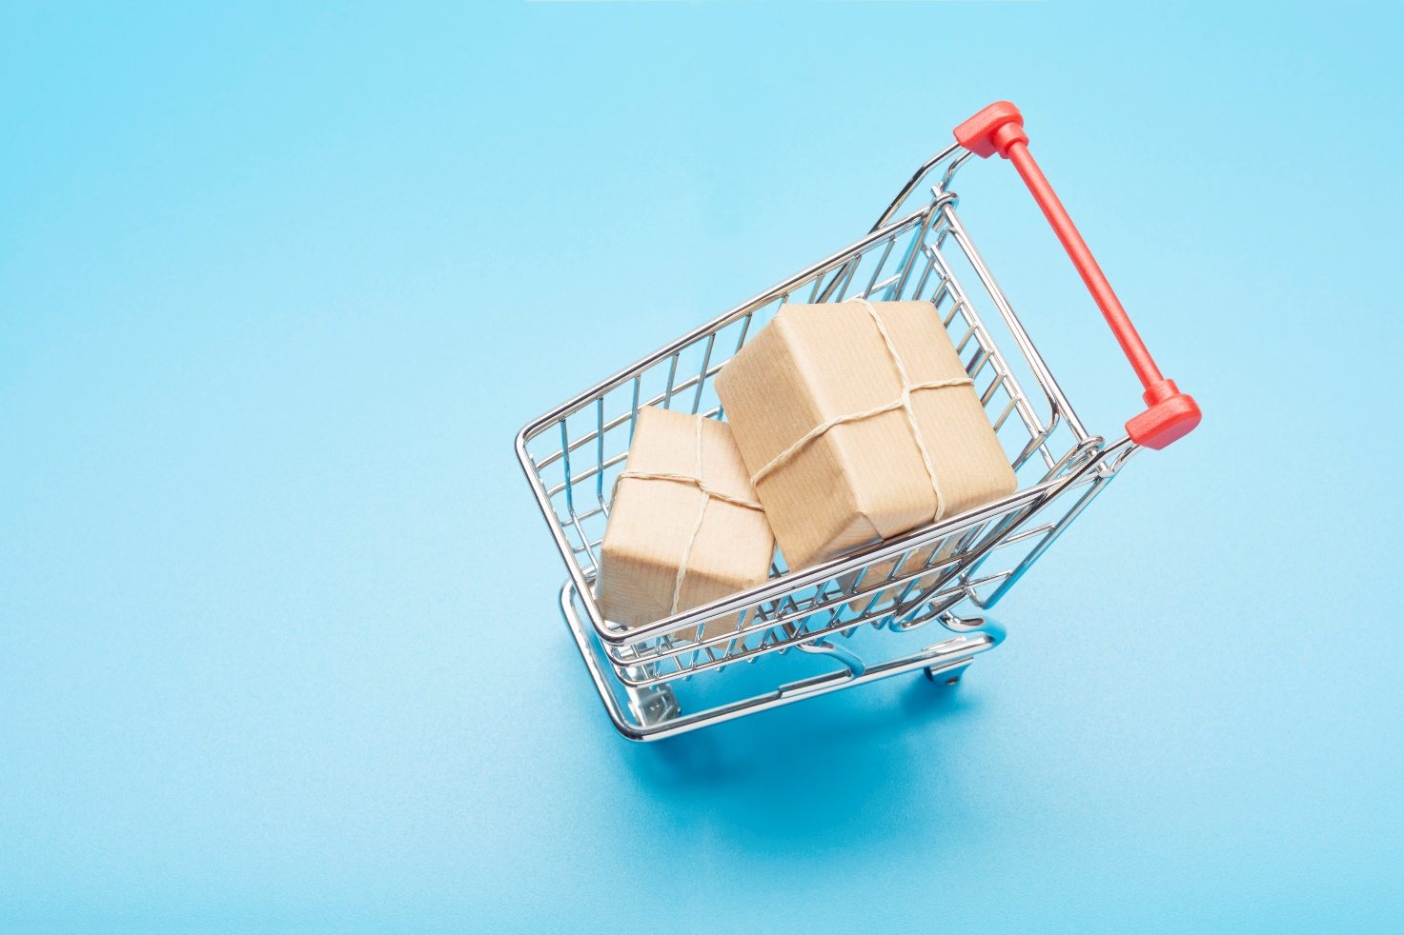

November 2022

Contents

Executive Summary 3
Background 4
Methodology and sampling 5
Key findings 6
Conclusions 10
Recommendations 10

Executive Summary

The UK officially left the EU on 31st January 2020. Northern Ireland is the only part of the UK which has a border with an EU member state, that is, the Republic of Ireland (‘ROI’). Under the terms of the Brexit withdrawal agreement, Northern Ireland continues to participate in the European Single Market in relation to goods and to be a de facto member of the EU Customs Union. The Northern Ireland Protocol was developed and agreed by the UK Government and the EU. In the last two years we have heard from our stakeholders in Northern Ireland that the cost of purchasing goods to be delivered to Northern Ireland from Great Britain (GB) has increased, in terms of the costs of items and the cost of postal surcharges. People have also encountered problems with obtaining some items from GB as companies have stopped sending certain goods to Northern Ireland. To gain more information about this issue, we commissioned this research to find out more about Northern Ireland consumers’ experiences of the parcel service since EU Exit. Based on our findings, we make a series of recommendations aimed to improve consumers’ current experiences.

Online shopping
Overall, more than nine in ten NI participants shop online (91%). Younger people are significantly more likely to shop online compared to older people. The majority of participants either received parcels every week or less than once a month. These parcels largely came from the rest of the UK (England, Scotland and Wales) or from within Northern Ireland. Since the UK left the European Union about half (49%) of participants have noticed a change in the postal service for parcels. The main change was that delivery times have increased (66%) but about a quarter of participants had experienced an increase in cost, either to send the parcel (25%) or to receive the parcel (22%). Almost three in ten (29%) had experienced additional charges for parcels because of where they lived and for half of those the cost increase came directly from the retailer.

Satisfaction before UK left the EU with parcel delivery and access to a range of goods
Overall, nine in ten participants were satisfied with their parcel delivery service (89%) and their access to a range of goods online (90%) before the UK left the EU. However, satisfaction has significantly decreased by almost a third since the UK left the EU for both parcel delivery service (65%) and access to a range of goods online (66%). For those who did experience problems returning parcels, cost was the main factor.

Access to same retailers and products
Just over a quarter (26%) report they do not have access to the same retailers as they did before the UK left the EU. Those who reported this mentioned a number of retailers whom they had experienced, or they believed to be no longer delivering goods to Northern Ireland - the main group was Amazon retailers. Although some have since recommenced delivering to Northern Ireland. Just over a third of participants now find it difficult to buy particular types of products online. For these participants the main products that are difficult to source are electronics (22%) and plants (17%). For those who may have to source alternative products, as the ones they previously bought are no longer available online or have become difficult to source online, then they generally choose between three options: try to find an alternative (53%), buy locally (49%), or a lesser alternative is to go without (15%).

Background

The Communications Consumer Panel is the statutory consumer panel for the communications sector. We are a group of independent experts responsible for ensuring the citizen and consumer voice is represented in communications policy development. We ensure that the sector works for consumers, citizens and micro-businesses, particularly people who may be in a more vulnerable position in society. We represent the interests of consumers in England, Northern Ireland, Scotland and Wales.

The UK officially left the EU on 31st January 2020. Northern Ireland is the only part of the UK which has a border with an EU member state, that is, the Republic of Ireland (‘ROI’). Under the terms of the Brexit withdrawal agreement, Northern Ireland continues to participate in the European Single Market in relation to goods and to be a de facto member of the EU Customs Union and the Northern Ireland Protocol was developed and agreed by the UK Government and the EU. The protocol aims to do several things, specifically to avoid a hard border between NI and the ROI; to make sure of the integrity of the EU's single market for goods; to facilitate unfettered access for NI goods to the GB market, and the inclusion of NI goods in free trade agreements between the UK and third countries.

As the statutory consumer panel for citizens, consumers and micro-businesses using the UK communications sector (including the postal services sector) the Communications Consumer Panel has no official position or comment on the fact that the UK has left the EU. However, all widescale political and economic changes can have consequences for UK consumers, citizens and micro businesses. It is our role to voice concerns on behalf of those affected – or likely to be affected – by changes to the way communications services operate. We have a particular focus on strengthening the voice of those who may be less heard in policy-making and industry plans. We make measured policy recommendations to those who can make a difference to consumers in the communication sector. In the last two years we have heard from our stakeholders in Northern Ireland that the cost of purchasing goods to be delivered to Northern Ireland from Great Britain (GB) has increased, in terms of the costs of items and the cost of postal surcharges. People have also encountered problems with obtaining some items from GB as companies have stopped sending certain goods to Northern Ireland. To gain more information about this issue, we commissioned this research with the following objectives:

- To find out more about Northern Ireland consumers’ experiences of the parcel service since EU Exit.
- To discover any effects of additional customs paperwork and surcharges that are placed on some parcels being delivered within the UK context
- To understand whether some retailers have stopped delivering to Northern Ireland following EU Exit and if there are items NI consumers are missing out on/having to source elsewhere.

Methodology and sampling
The research was conducted via Ipsos Northern Ireland’s virtual telephone centre. 503 interviews were conducted via telephone interviewing using Computer Assisted Telephone Interviewing (CATI) from Ipsos’ Northern Ireland virtual telephone centre.

A representative sample of the Northern Ireland population was achieved. The most recent data from the Northern Ireland Statistics and Research Agency (NISRA) confirms that 21.7% of people in Northern Ireland state that they have a disability or long-term illness which affects their daily lives. We also set a quota to ensure that at least 21% of the achieved sample had a disability/long term illness in line with 2011 census data. We also defined the following groups which were to be used for segmentation: financial, digital and/or literacy/numeracy vulnerability. Participants self-reported urbanity and had 68% urban and 31% rural. The Northern Ireland Research and Statistics Agency report that 65% of the Northern Ireland population live in urban areas and 35% in rural areas. Hard quotas were set in accordance with the 2011 Census data. They are as follows:

Age |  | Location
16-29 | 25% | Belfast City | 16%
30-44 | 26% | Greater Belfast | 22%
45-59 | 24% | Co. Down | 16%
60+ | 25% | Co. Armagh | 8%
Social Class |  | Co. Tyrone/ Co. Fermanagh | 13%
ABC1 | 44% | Co. Derry | 13%
C2DE | 56% | Co. Antrim | 11%
Gender
Female | 52%
Male | 48%

Key findings

Customer reliance with parcel delivery services in Northern Ireland

- Northern Ireland has a strong online shopping community - 91% of people shop online to receive or return parcels. This was lower in the group of people who said they had a ‘mental or physical disability or long-term illness’, but still high at 84%.
- Younger people are more likely to shop online compared with older people. Those under 45 years old (18-29, 96% and 30-44, 95%) were more likely to shop online than those over 45 years (45-59, 88% and 60+, 85%).

Frequency of receiving parcels

- The majority of participants (61%) tended to receive parcels at least once a month: daily (6%), every week (44%), multiple times per month (7%) or once per month (4%).
- Those aged 30-44 are most likely (53%) to receive parcels every week, particularly compared with those over 60 (35%).
- Older participants (48%) were more likely to receive parcels less than once a month compared with those under 45 years (16-29, 34% and 30-44, 30%).

Point of origin

- The majority of participants (74%) tended to receive parcels from England, Scotland or Wales and about a third (34%) received parcels from within Northern Ireland.
- To a much lesser extent about a fifth of parcels are received from the rest of the world (22%) and Europe (19%) and just over a tenth (12%) from the Republic of Ireland.

Noticed changes to the postal service

- About half of participants (49%) have noticed a change in the postal service since the UK left the European Union.
- Of those who had noticed a change, the main one that people noticed was that delivery times have increased, (66%).
- About a fifth to a quarter have noticed that the cost of sending a parcel has increased (25%) and the cost of receiving a parcel has increased (22%).
- There have also been issues with delivery of parcels - either parcels are simply not delivered (16%) or companies are no longer delivering to Northern Ireland (15%).

Q3a. Since UK (Northern Ireland) left the European Union, have you noticed a change in the postal service for parcels?
Q3b What changes have you noticed? Base: All respondents (501)

Parcel surcharges

- Of those surveyed, 29% had experienced additional charges for parcels because of where they lived.
- 51% stated that surcharges had come directly from the retailer and 32% reported that the additional charges had been directly from the delivery company.
- 26% did not know the source of the additional charges. This could be an issue with memory recall, but equally it could highlight a lack of transparency in the purchase or delivery process.

Satisfaction with delivery and range of goods available

- Before the UK left the EU satisfaction with parcel delivery services was 89%. It is now significantly lower at 65%.
- Before the UK left the EU satisfaction with access to a range of goods online was 90%. It is now significantly lower at 66%.
- Just over one in ten (11%) reported that they have had problems returning a parcel to GB retailers since the UK left the EU. There is no difference among the age groups but females (13%) report more difficulty than males (7%) returning items to GB retailers. Those living in Belfast City Centre (19%) are more likely to report difficulties than those in the wider Greater Belfast Area (6%) or in Co. Down (7%). A greater number of people with a disability/long term illness report they have more difficulty returning a parcel to GB retailers (17%) compared with those with no disability/long term illness (8%).
- Those who are more confident with working out their own personal finances, confident filling out official forms and confident following instructions are more likely NOT to have issues returning goods (88%, 87% and 87% respectively) compared to those who are not confident (76%, 78% and 79% respectively).

Access to same retailers

- Two thirds of participants (67%) reported that they have access to the same retailers online now as they did before the UK left the EU. Those under 45 (16-29 years, 72% and 30-44 years, 76%) are more likely to say that they have access to the same retailers now as they did before the UK left the EU than those over 45 (45-59 years, 57% and 60+ years 64%). Males are also more likely to report having access to the same retailers now as before (72%) compared with females (62%).
- Those who are less confident reading instructions are also less likely to think they have access to the same retailers now as before (51%) compared to those who are confident reading instructions (70%). Those living in the greater Belfast area (36%) are more likely to say that they did not have access to the same retailers online as they did before compared with those living in Co. Derry/Londonderry (18%) and Co. Antrim (19%).

Retailers who will not deliver goods to NI

- Those who reported they no longer had the same access to retailers mentioned a number of retailers whom they had experienced, or they believed to be no longer delivering goods to Northern Ireland - the main group was Amazon retailers. By this they mean the retailers who trade through Amazon.
- However, John Lewis and eBay were also mentioned along with Thompson and Morgan who sell plants and seeds and made.com (who make bespoke furniture and soft furnishings). In addition, there were also 36 other companies which individual participants mentioned that are no longer delivering goods to Northern Ireland.
- Over two fifths (43%) of those who report that they no longer have access to the same online retailers as before the UK left the EU could not remember the names of the individual companies.
- Only a few participants were able to name retailers that are now delivering to Northern Ireland again and these were Amazon or some of the Amazon retailers, Debenhams, eBay, John Lewis and M&S. The majority were not aware of any.

Particular types of products that people now find it difficult to buy online

- Just over a third of participants now find it difficult to buy particular types of products online. For these participants the main products that are difficult to source are electronics (22%) and plants (17%).
- After these two main items the next most difficult items to source are certain food types (13%), clothing (11%) and furniture and beauty products (10% respectively). This ties in with the retailers that participants mentioned earlier as no longer delivering to Northern Ireland, e.g. Thompson and Morgan who sell plants and seeds and made.com and also the Amazon retailers.

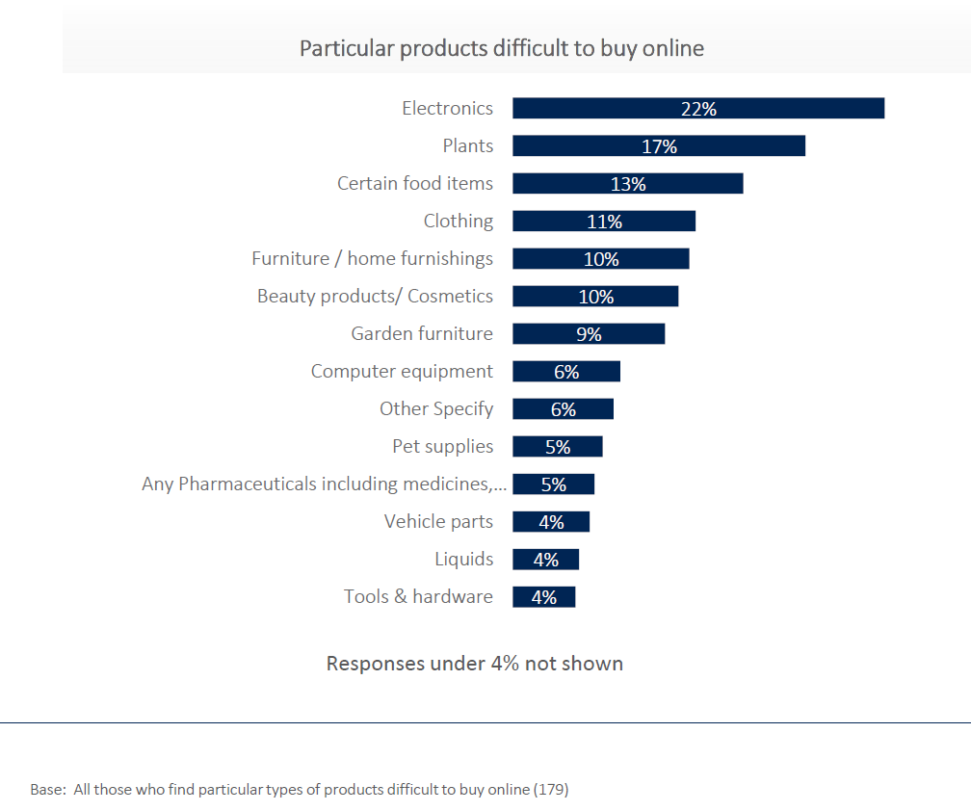

Sourcing alternative products

- For those who may have to source alternative products as ones they previously bought are no longer available online or have become difficult to source online then they generally choose between three options: try to find an alternative (53%), buy locally (49%), or a lesser alternative is to go without (15%).
- Those who report that their current level of digital skills limits what they can do online are much less likely to try to find an alternative (31%) compared to those who are not limited by digital skills (58%). Similarly, those who are confident completing official documents are more likely to source alternatives (57%) compared to those who would not have confidence in their ability to complete official forms (34%). It could be hypothesised that someone who is not confident in completing official forms may also feel uncomfortable completing new payment details on an unfamiliar site.
- Those under 45 (18-29 years, 54%, 30-44 years, 57%) and over 60 years (51%) are much more likely to buy locally as an alternative than those aged 45-59 years (32%). Those living in Belfast City Centre are more likely to buy locally (64%) than those living in Co. Armagh (33%). There are significantly more outlets to choose from and source alternatives in Belfast City Centre than in Co. Armagh. Those in socio-economic group ABC1 are more likely to source local (56%) compared with C2DEs (40%). Again, accessibility may be a dimension here as those in the higher socio-economic groups have potentially more access to transport.
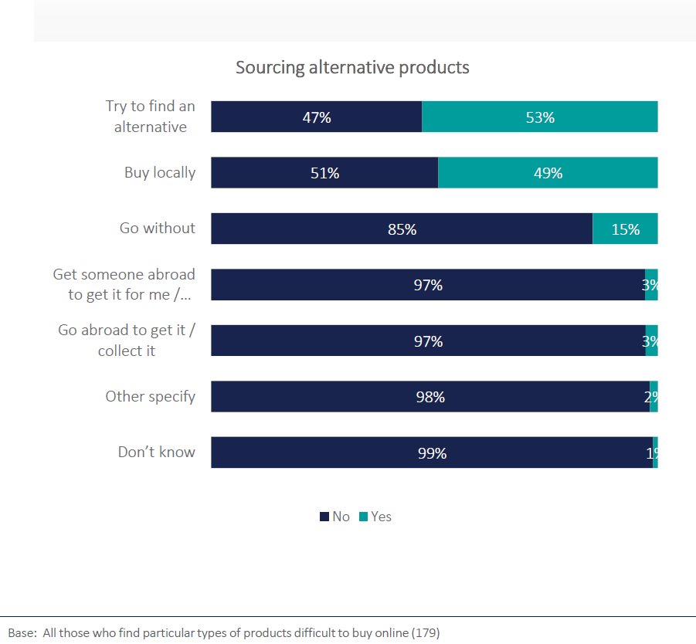

Conclusions
We strongly believe that consumers in Northern Ireland, as in all parts of the UK, should have access to fair, cost-effective and reliable parcel delivery services. This research highlights clear detriment for parcel service users and online shoppers in Northern Ireland. With 91% of consumers with access to the internet in Northern Ireland shopping online, the reliance this part of the UK has on parcel delivery services is clear, so there is a level of additional detriment in charging them more to access it. A collaborative approach is required to resolve the difficulties that parcel consumers in Northern Ireland are facing as the issues go beyond any regulatory remit. We would make the following recommendations:

Recommendations
- Greater transparency of costs and delivery conditions from retailers and parcel delivery companies. This also relates to locations beyond Northern Ireland where parcel surcharging and restrictions on delivery take place (Scottish Highlands and Islands, for example).
- Parcel delivery companies and retailers should have – and live up to – a customer charter to highlight what level of service they will guarantee to customers across the UK, including in specific locations which may be harder or more costly for the company to deliver to.
- Automatic compensation for consumers who order ‘Next Day Delivery’ or other guaranteed delivery options where the delivery company fails to deliver on its promises - if the delay is the retailers’ fault, then it should be the parcel delivery company’s responsibility to recover costs from the retailer, the burden and cost should not fall on the consumer.
- Ofcom and consumer bodies should collaborate on and publish a checklist of the most accessible and cost-effective ways to send parcels, such as making consumers aware of services available to people who require additional access support and tips and ideas on spreading the cost (for example, splitting a large parcel into two small ones can work out cheaper).
- The UK and devolved Governments should work with industry to find a solution to parcel surcharging that leads to fairness in parcel delivery across the UK.
- Ofcom and consumer bodies should work together to consider whether it would be practical and helpful to set up ‘central depot units’ for parcel delivery across hard-to-reach areas such as Northern Ireland, Scottish Highlands and Islands and parts of rural England and Wales. In previous Panel research we heard that ‘Click and Collect’, which can be a cheaper alternative to having an item delivered to your home, is often not available to people in rural areas;
- A discount loyalty scheme could be set up by Royal Mail, for customers who send or receive parcels more regularly. In previous Panel research, we heard that micro-business owners prefer to use Royal Mail to give their customers assurance that the item would arrive when they promised.

