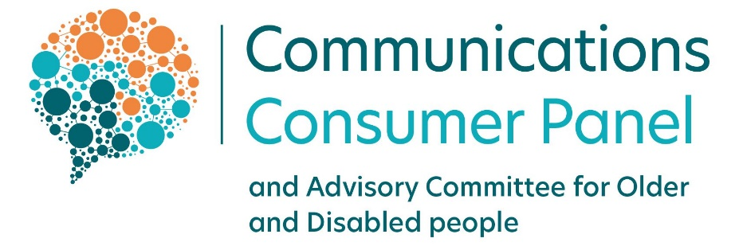

Migration to VoIP: listening to the needs of landline consumers

Quantitative research into the needs of landline telephony consumers

September 2022

Contents

Migration to VoIP: consumers’ needs 1
Contents 2
Foreword 3
Context 4
Background 5
Methodology and sample 7
Key Findings 8
The Panel’s recommendations 18

Foreword

“The landline is almost like the ‘old faithful’ in my life… Mobiles aren’t always the most reliable. It’s always been there and it connects my other systems [care alarm] so it makes a big difference to me”
- participant in the Communications Consumer Panel’s 2021 qualitative research

Communications consumers deserve high quality, affordable, reliable and secure services – this is now as important as the right to access utilities. The current UK traditional telephone network – the Public Switched Telephone Network (PSTN) is reaching the end of its life and needs to be upgraded. Broadly, by the end of 2025, consumers currently using a traditional landline will be migrated over to using landline telephones over Voice over Internet Protocol (VoIP) technology.
The role of the Communications Consumer Panel, as statutory consumer panel for the communications sector, is to represent consumers in this sector – particularly those whose voices may otherwise be less likely heard by policy-makers and industry. That includes users of landline telephony, whether as a residential customer or a micro business. We believe that migration to VoIP needs to be handled carefully to protect the safety of consumers who use additional telephony services such as a telecare alarms or remote health monitoring, and people living in areas where they cannot rely on a strong, reliable mobile signal.
Alongside getting the technology right – with advance testing facilities in place requiring collaboration between the likes of telecare alarm providers and communications providers, and alternative technological solutions for consumers, such as battery back-up and hybrid handsets - we believe that raising the overall awareness of consumers and micro businesses is vital. This matters so that consumers can share with their communications provider any additional service requirements that they may have had no reason to mention before, so that their provider can best assist them – and to arm them with clear information to protect them from falling foul of scams.
We remain convinced that there needs to be a wide-ranging communications campaign around this industry-led change. We have welcomed industry’s engagement on this issue and look forward to continued collaborative working to influence change, along with the National Stakeholder and Consumer Advocacy Hubs, Ofcom, DCMS and devolved government stakeholders.
Any wide-ranging communications campaign should – we believe – be informed by the consumer voice. So, we took the opportunity to look more deeply into the issues we heard from consumers who participated our qualitative research last year (published here: Switchover from analogue to digital telephony: UK consumer and micro-business reactions (2021) - Communications Consumer Panel) and commissioned this extensive survey of 4612 consumers with a landline around the UK.
Our qualitative and now quantitative research into migration to VOIP has highlighted the continued importance of the landline for many UK consumers and their dependence on it during power cuts:
- Nearly two thirds (62%) of our sample still used a landline to make calls, that figure rising to 75% of over-65s and 69% of people surveyed who self-identified as disabled. In those surveyed by telephone, 91% of over 65s and people who self-identified as disabled reported still using their landline to make calls.
- In terms of mobile network connectivity, 2% of people who had a mobile were using a 2G connection, 10% a 3G connection and 13% didn’t know. People aged 65+ were more likely than the general population to have a 2G (3%) or 3G (14%) connection.
For us, this shows that having a mobile is not a secure enough back-up in an emergency, particularly given the move away from 2G and 3G services by industry, in favour of 4G and 5G services.

- From our UK-representative sample of those with a landline, 3% of the overall sample said had a said they had a Telecare alarm (such as a pendant or bracelet) – 7% of the sample that were interviewed by telephone; 1% of the overall population and 2% of those interviewed by phone said they had remote health monitoring, described as ‘Medical Services that require an internet connection so that your doctor or hospital can monitor your health while you're at home’.
- Regarding power cuts, 64% of our sample had experienced a power cut in the last two years (84% of respondents in rural areas), with 32% of those saying the power cut had lasted between one and 24 hours.
- 48% of respondents were aware of migration to VoIP by 2025 – awareness was higher among people aged 65+ (53%), men (54%), AB households (55%) and people from a minority ethnic background (54%). 52% of people said they hadn’t heard about the VoIP migration. 18–34-year-olds (57%), 35-54s (55%), women (57%), people from C2DE households (57%), or a disability (58%) or low digital literacy (56%) were less likely than average to have heard.
- In terms of how people would like to be informed about migration, the channels were ranked as email (69%), letter (54%), TV advert (29%), leaflet (22%), radio (10%), text (10%), phone call (8%) and online video (7%). While using this as a guide, we would expect communications providers to take account of their customers’ individual communications preferences and requirements, so that each of their customers has time to make preparations where needed.

- Overall, respondents across our sample wanted answers to these questions: whether their bill would change (59%), whether their number would change (48%), how reliable VOIP might be (38%), whether they needed to buy another phone (38%), whether they could use their phone in a power cut (35%), who would help them set up the phone system in their home (22%) and what features VOIP has e.g. voicemail, call waiting, last number dialled (20%).

We’ve been working closely with policy makers, industry and stakeholders around the UK to ensure we have a shared understanding of the potential impacts of the migration – particularly on customers who have additional telephony service requirements – and the mitigations that need to be put in place.
We believe that now is the time for communications providers to listen to the needs of their customers, particularly those who may not want to label themselves as ‘vulnerable’, but who may benefit from extra support. We prefer not to label discrete groups of consumers as ‘vulnerable’, instead recognising that any consumer can become vulnerable at any time. It is by listening to their customers’ additional service requirements that communications providers can empower individuals to feel less vulnerable in the communications sector.
We know from our engagement with industry and research that often the support is available, but all too often consumers are unaware of it, or of what to ask for. We look forward to continued work with industry, government, Ofcom, consumer groups and others to help consumers to access the support that can help them use communications services safely and effectively.

Context
The current UK telephone network – the Public Switched Telephone Network (PSTN) is reaching the end of its life and needs to be upgraded. In future, landline calls will be delivered over digital technology, called Voice over Internet Protocol (VoIP) - also referred to as ‘digital phone’ or ‘digital voice’. Broadly, by the end of 2025, consumers currently using traditional landlines will be migrated over to using landline telephones over VoIP technology. As Ofcom has noted, this is not only happening in the UK. These changes are taking place all over the world, with many countries having now completed them. The Panel strongly believes that we should learn from the successful strategies employed elsewhere e.g., Australia and we have been working with Government, policy makers and industry to share this knowledge.
Ofcom has also noted in its policy positioning statement on the Future of Fixed Telephone Services that, for most customers, switching to VoIP should be straightforward and they will continue to receive what they recognise as a traditional phone service. While all landline customers will eventually need a broadband connection to continue receiving a phone service, they will still have the same phone number and use phone numbers to make and receive calls.
However, unlike traditional corded analogue phones, a digital phone will only work in a power cut if it has a battery back-up. If a consumer is dependent on their landline phone – for example, if they don’t have a mobile phone or don’t have a mobile signal at their home – providers must offer consumers a solution to make sure they can contact the emergency services when a power cut occurs. This could take the form of a mobile phone (if there is a signal), or a battery back-up unit for their landline phone providing a minimum of an hour’s access to emergency services. This solution should be provided free of charge to people who are dependent on their landline. If consumers need any new equipment to make their landline phone work – for example, a new router, new telephone handset or if they need a new broadband service installed, their provider should arrange this.
Ofcom has published consumer information on its website noting that when the time comes for a consumer’s landline phone to be upgraded, people should talk to their provider about their circumstances and how the service will work for them e.g. if they need extra help to change their service over, if they are dependent on their landline phone to make calls in a power cut, or if they use equipment connected to their phone line such as a telecare or burglar alarm.
Certain devices such as care alarms, security alarms and fax machines connected via a landline might need to be replaced or reconfigured to continue working once a consumer moves to a VoIP service – and the alarm provider informed by the consumer so they can make the necessary changes or tell them if the alarm will work with the new VoIP service. Similarly, consumers buying a new alarm or device should ask the manufacturer if it is compatible with VoIP services.
Like residential customers, small businesses that want to continue using their landlines will have to move to VoIP services and might also have equipment such as card payment machines, alarms, and monitoring equipment connected to their landline that might not work once they have migrated to a VoIP service.

Background
In May 2021, we held a UK-wide webinar with Openreach to answer questions from consumer organisations and charities to help raise awareness and to encourage organisations to prepare for the change to VoIP. We had been concerned by the lack of information proactively provided about the VoIP switchover, which had resulted in low levels of awareness and a hunger for more information amongst relevant organisations who could help support consumers.
Also in 2021, we commissioned in-depth, qualitative research with residential and business audiences across the UK to understand awareness and perceptions of the switchover to VoIP, the confidence of customers to carry out the switchover and their ability to identify what type of additional support may be needed. We also wanted to explore the potential impact of the switchover if mitigations were not put in place – such as care alarms ceasing to work, phone extensions not functioning, consumers spending money on telephone equipment that had become obsolete, and people being unable to make emergency calls on their landline during a power cut.
That research highlighted that while the majority of participants in the research accepted the need for the switchover, there were questions that they felt needed answering. Consumers need time to understand the change and to take action – including checking that the switchover is genuine and looking into any new equipment that they may need to buy, to ensure it will work. Some consumers may need even more time and may need to seek advice or need an engineer to help with the installation.
We identified a risk that, in the preparations for migration to VoIP, some people’s circumstances did not appear to have been given sufficient consideration. We have used the findings of that qualitative research to inform our advice to Governments, policy makers and industry. The onus is clearly on providers to initiate the switch and to support customers to migrate, providing the necessary instructions and hands-on support. This may involve providing extra help to people with additional access requirements. We believe that without a structured and closely monitored plan, some consumers may be migrated too soon, putting them at risk, without the support they need. The Panel has emphasised to Ofcom, DCMS and industry that to protect consumers from harm, the switchover needs to be carefully managed by raising awareness of the impending changes – similar to the communications model adopted in Australia ‘Check, select, connect’ - and proactively identifying consumers who might need additional support throughout the migration process. A comprehensive communications plan would achieve these aims and also see people protected from the type of scams that we know can arise from any major industry change.
To build our knowledge base in this vital area and look more deeply into the issues we found last year, we have commissioned this extensive survey of 4612 consumers with a landline around the UK. We hope that our recommendations and the findings from the research will assist policy makers and industry to invest in timely action to make migration to VoIP a success for UK consumers and small businesses – and provide the information needed by industry to enable providers to navigate away from avoidable risks.

Methodology and sample
- Yonder conducted a total 4612 interviews, of which 4247 were online (between the 22nd and 27th March 2022) and 385 were conducted by telephone (between 1st and 7th April 2022). All respondents had a landline at home.
- We supplemented the online sample with telephone interviews to increase the likelihood of hearing from consumers who were less confident using the internet.
- All respondents were UK adults aged 18+, who had a landline connection at home; surveyed as part of Yonder’s nationally representative online omnibus.
- Boost interviews were conducted in Wales and Northern Ireland to achieve a robust sample size for analysis.
- Data has been weighted to the known profile of the UK using age, gender, government office region, social grade, tenure, ethnicity, and working status.
- Targets for quotas and weights are taken from PAMCO, a random probability F2F survey conducted annually with 35,000 adults. This provides us with a more accurate measure of demographic composition in the absence of any up-to-date census information.
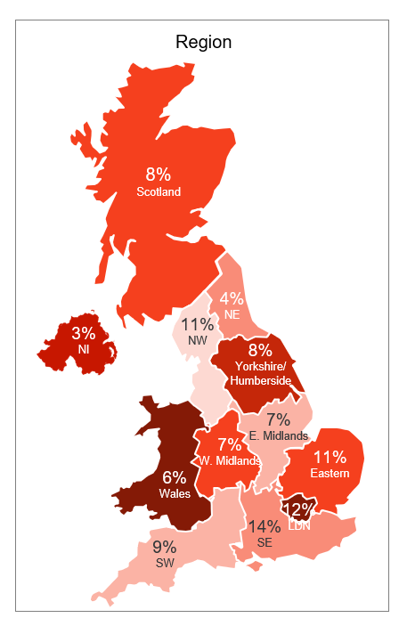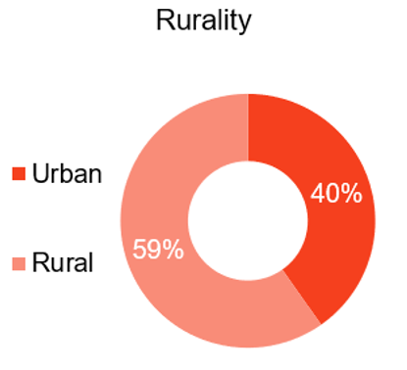
Profiling: 4612 respondents.

Key Findings

Landline and mobile phone use
- 62% of people make calls using their landline from home – and this is higher for some groups: those aged 65+ (75%), rural dwellers (67%), disabled people (69%), and people with low digital literacy (67%). In our sample responding by telephone, this rose to 91% for both those aged over 65 or disabled people.

Chart 1: DEVICE USED TO MAKE CALLS AT HOME
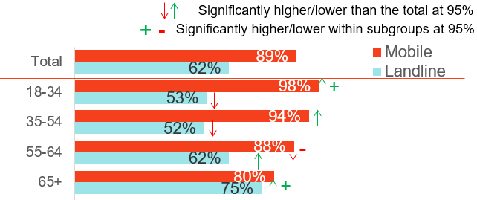
Q1. How do you make calls when you are at home? Base: All respondents (4612)
- Just over a quarter of people with landlines (26%) said they had a corded phone in the house. This rises to 30% among people with low digital literacy, 33% amongst 18-34s, and 33% among people from minority ethnic groups. In our sample responding by telephone, this reached 40% of those aged 65+.

- The landline is the preferred device for making calls at home for 34% of people overall – more so for 55-64s (38%), those aged 65+ (54%), rural dwellers (42%), people with low digital literacy (38%), DE households (38%), or disabled people (47%).

Chart 2: PREFERRED DEVICE TO MAKE CALLS AT HOME
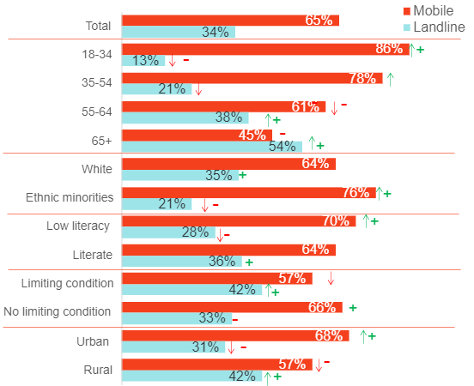

Q2. What is your preferred device to make calls at home? Base: All respondents (4612)
- While a landline is considered important for making and receiving calls by 37% of people with a landline in general, this is more so for older consumers aged 65+ (49%) people from a minority ethnic group (43%), disabled people (52%), people with a physical disability (46%), those living in a rural area (41%), people in DE households (42%) or with low digital literacy (50%). Among our sample responding by telephone, this rose to 66% of those aged over 65 and 72% of disabled people.
- Many people already use mobiles to make calls from home (89%) – indeed 65% of respondents preferred to use them at home over other devices.
- In terms of network connection, 2% of people who had a mobile were using a 2G connection, 10% a 3G connection 75% a 4G or 5G and 13% didn’t know. People aged 65+ were more likely than the general population to have a 2G (3%) or 3G (14%) connection.
- However, 11% of our sample said they didn’t use a mobile to make calls from home – and that rose to 17% of disabled people and 20% of those aged 65+.
- 2% of people said that they don’t have a mobile – rising to 3% of DE households, 4% of people aged 65+, people living in Scotland (4%), or people with low digital literacy (4%). Amongst our sample responding by telephone, 17% of those aged 65+ did not have a mobile.

Power cuts
- 64% of respondents had experienced a power cut in the last two years – rising to 84% of people in rural areas. Overall, 27% had experienced one power cut, 19% had two power cuts, 8% had three power cuts and 11% had over four. In rural areas the pattern differed - 20% had one power cut, 21% had two, 14% had three and 29% over four power cuts.
- 67% of people who had experienced a power cut in the last two years said that, on average, power cuts lasted for up to an hour, 32% 1-24 hours and 1% more than a day. In rural areas, 3% said the average was more than a day. Participants living in Northern Ireland were more likely to report an average duration of 1-24 hrs (46%), while those in Scotland were more likely than average to report 24 hrs + (4%), as were people in North-East England (5%).
Chart 3: EXPERIENCE OF POWER CUTS

Q21. How many power cuts have you experienced in the last 2 years? Base: All respondents (4612). Q22. On average, how long do any power cuts you experience last for?
Q23. How long was the longest power cut you've experienced in the last two years?
Base: All who experienced a power cut (2,957).

- In terms of the longest power cut in the last two years, 52% of people said they were without power for up to an hour, 44% for 1-24 hours and 4% for more than a day. In rural areas, 37% said up to an hour, 55% 1-24 hours and 8% more than a day. People living in Northern Ireland were more likely than average to say the longest cut was 1-24 hours (61%) and people living in Scotland (11%) and North-east England (9%) to say more than a day.

Summoning help
- During the last power cut they experienced, 14% of people needed to call for help or check on somebody. This was higher for 18–24-year-olds (23%), 35–44-year-olds (19%), people in Scotland (20%), London (25%), people from a minority ethnic group (32%) and people with low digital literacy (21%).

Chart 4: THOSE THAT NEEDED TO CHECK ON ANYONE OR CALL FOR HELP DURING LAST POWERCUT
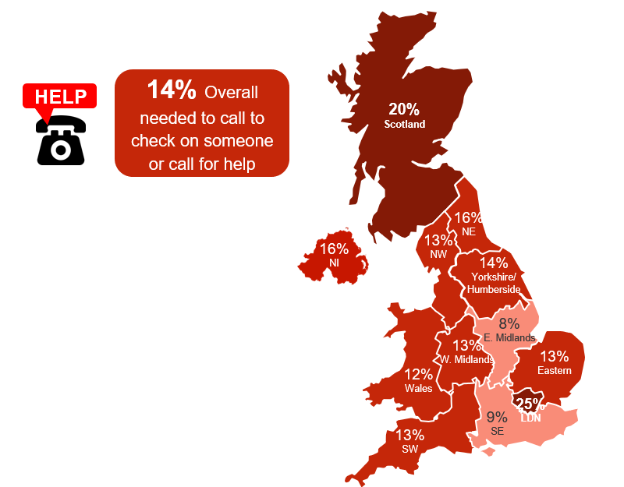

Q24. During any recent power cut did you need to call to check on anyone or call for help. Base: All who experienced a power cut (2,957)

- 62% of participants would use their mobile in an emergency but 36% would turn to their landline – a preference for the landline was more likely among 55-64 (41%), those in the South West (46%), aged 65+ (55%), people in rural areas (46%), and disabled people (44%).
Chart 5: DEVICE THAT RESPONDENTS WOULD USE IN AN EMERGENCY

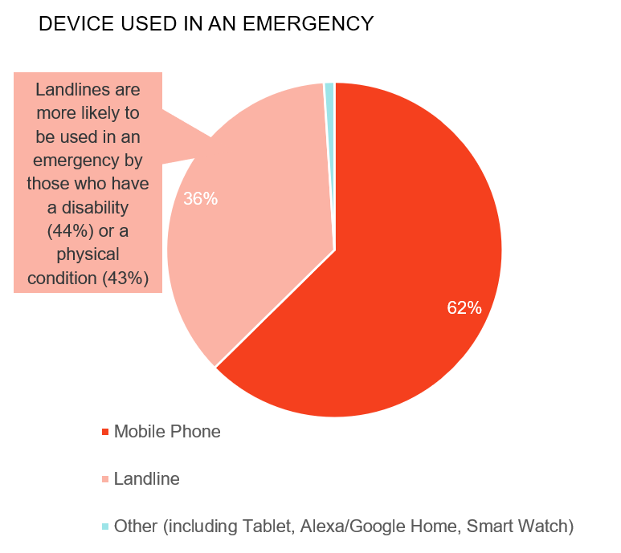
Q12. If an emergency happened at home and you needed help, what device would you expect to use to make an emergency phone call to someone to help you? Base: All respondents (4612)

- 14% of participants reported that they did not have a mobile signal strong enough indoors at home to make a call – 22% of people in Wales, 23% in the South West and 26% in rural areas.

- The main reason given by people who said that they would choose to use their landline rather than their mobile in an emergency was ease of use – 57% of people said this but this was higher among those aged over 65 (65%).

Chart 6: REASONS FOR USING A LANDLINE IN AN EMERGENCY RATHER THAN A MOBILE

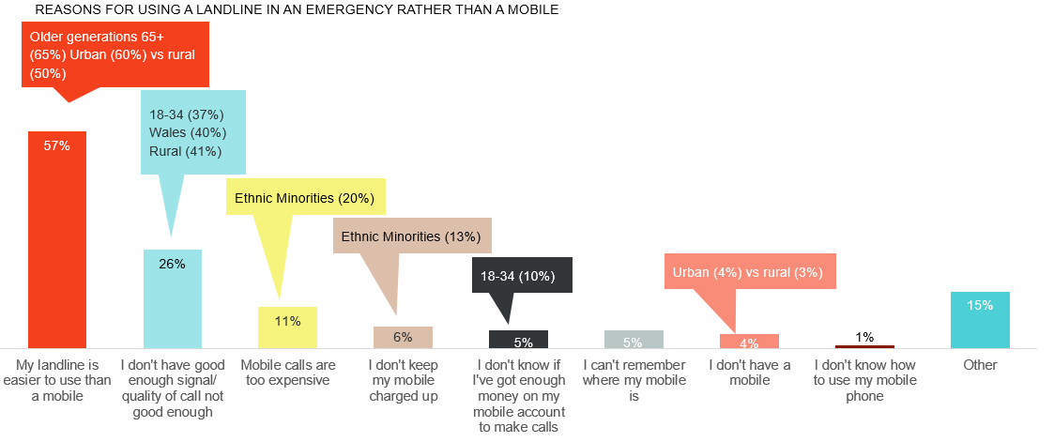
Q14. Why would you use your landline and not a mobile phone? Base: All who would use landline in emergency (1726)

- Poor signal connections were given as the reason by 26% of people overall and those in Wales (40%) and rural areas (41%) were more likely to say that they would use a landline rather than a mobile for this reason in times of emergency.
- 11% of people said mobile calls were too expensive and 6% said they didn’t keep their mobile charged up – both categories saw higher levels of response from people in minority ethnic groups* (20% and 13% respectively). 5% didn’t know if there was enough money on their phone to make a call (while calls to emergency services would be free, calls to other sources of help e.g., family/neighbours wouldn’t necessarily be) – higher levels of response were given by people aged 25-34* (13%) and 35-44 (14%), and people from minority ethnic groups* (11%). 5% of people said they couldn’t remember where their mobile was, which rose to 11% of 35–44-year-olds.
- In an emergency, 54% of people would call for help from the emergency services - men (61%), C1 households (58%), 55–64-year-olds and those aged 65+ were also more likely to call emergency services (61%) and (60%) respectively.

Chart 7: WHO RESPONDENTS WOULD CALL IN AN EMERGENCY

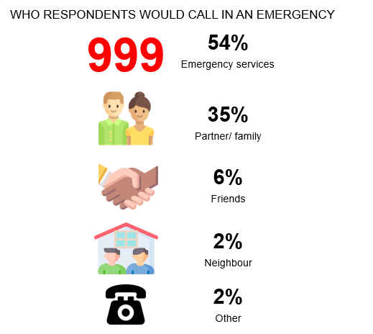
Q13. Who are you most likely to phone if you needed help in an emergency? Base: All respondents (4612)
- However, 35% would call their partner or family in an emergency - 18–34-year-olds (48%), 35-44s (42%), women (41%), people from C2 households (41%), people with low digital literacy (40%) and people from a minority ethnic background (40%) were more likely than average to call a partner/family.
- 6% would call a friend, with 18-34s more likely to do so (12%), as were people from minority ethnic groups (11%).
- 2% of people would call a neighbour – those aged 65+ were more likely to do so (4%)

Additional telephony services
- 8% of the general population have devices or service attached to their landline that support their health and safety. Of these devices, 3% of the general population had a telecare alarm, rising to 8% disabled people. Among our CATI sample, this rose to 8% of those aged 65+ and 20% of disabled people.

Chart 8: DEVICES CONNECTED TO LANDLINE
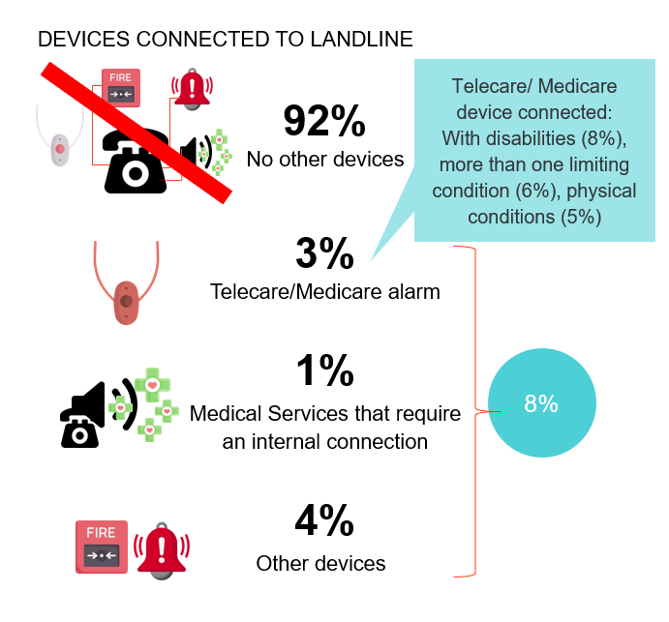
Q3. Do you have any other devices connected via your landline? Base: All respondents (4612).

- 1% of the general population had a remote medical monitoring attached to their line, enabling their doctor or hospital to monitor their health through a service powered by their current landline technology.
- These additional devices are considered important by 81% of the general population – which did not vary by sub-group. However, those aged 65+ (71%), living in rural areas (67%*), or with a disability (79%*) were more likely than the general population (55%) to say that they considered these devices to be very important.

Migrating to VoIP
- Of those people who had moved to VoIP (3%), 49% had not been asked any relevant questions such as whether they had a mobile, battery backup, devices connected to their line or disabilities by their Communications Provider. Of those that had been asked a relevant question, 39% were asked if they had a mobile, 18% if they had additional services e.g., telecare, burglar alarm, 11% if they had a battery backup and 11% if they had a disability or health condition.

Chart 9: QUESTIONS ASKED WHEN MOVING TO VOIP
(Caution: low base size, indicative only)
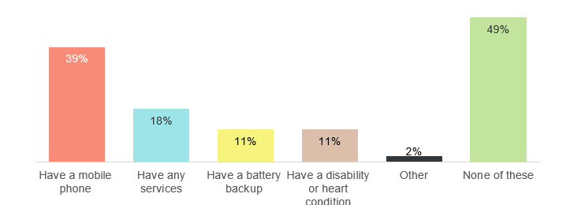

Q15. Before you changed to an internet phone where you asked if you….? Base: All with a VOIP phone (137)

- 48% of respondents were aware of the switch to VoIP by 2025 – awareness was higher among people aged 65+ (53%), men (54%), AB households (55%) and people from a minority ethnic background (54%).
- Overall, 52% of people said they hadn’t heard about the VoIP switchover. 18–34-year-olds (57%), 35-54s (55%), women (57%), people from C2DE households (57%), or a disability (58%) or low digital literacy (56%) were less likely than average to have heard.
- Of those that had heard, 38% had read about the change online, 21% in the newspaper, 20% from their communications provider, 14% from a family member or friend and 12% saw it on TV.
- 94% of people said they expected their Communications Provider to inform them about the migration– and this was greater among those aged 55+ (97%). 34% expected the Government to inform them, 21% Ofcom, 11% a consumer advocate and 8% family or friends (respondents selected an option from a drop-down list).
- In terms of how people would like to be informed the channels were ranked as email (69%), letter (54%), TV advert (29%), leaflet (22%), radio (10%), text (10%), phone call (8%) and online video (7%).
- Participants were asked what their top 3 questions about migration to VoIP would be – the most frequently highlighted were: whether their bill would change (59%), whether their number would change (48%), how reliable VOIP was (38%), whether they needed to buy another phone (38%), whether they could use it in a power cut (35%), who would help them set up the phone system in their home (22%) and what features VOIP has e.g. voicemail, call waiting, last number dialled (20%).

Chart 10: TOP 3 MOST IMPORTANT QUESTIONS ABOUT MOVE TO VOIP
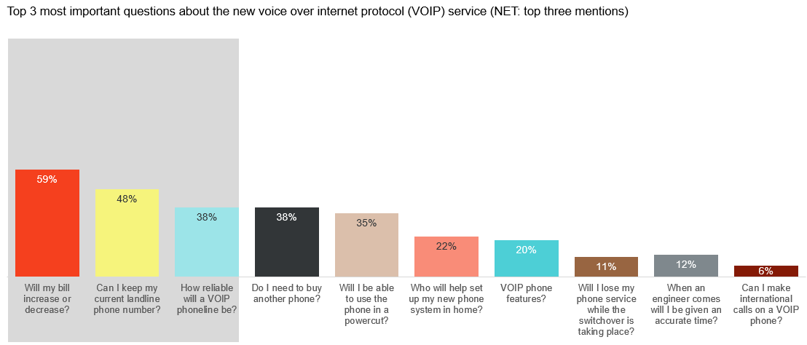
Q20. What are the top 3 most important things you would like to know about the new voice over internet protocol (VOIP) service? Base: All respondents (4612)

- When asked if they would be interested in a battery back-up device from their Communications Provider to help in case of a power cut, 54% of people said they would – this was higher among 25–34-year-olds (60%), people with a mental health condition (61%) and people from minority ethnic groups (62%). 19% said no – they either had a battery backup (3%) or didn’t want one (16%). 27% of people didn’t know whether they would want one – this was higher among those aged 55-64 (30%), 65+ (30%), DE households (30%) and women (30%).

The Panel’s recommendations
In readiness for the switchover, we have urged communications providers to:

- Get to know customers’ additional access requirements, so that their customers know they will be supported through the switchover and won’t have additional services - such as telecare - cut-off. To enable this, providers should promote widely any additional support to customers with additional access requirements. Communications Providers should already be used to taking advice from Ofcom’s Treating Vulnerable Customers Fairly guide.
- Take responsibility for informing customers (including those who are not online) of the changeover months in advance to ensure there are no unwelcome surprises and communicate more than once so that consumers cannot miss this information.
- Train staff to explain to customers simply why the change is happening and what benefits they will receive from it, as well as any precautions they need to take, using consistent language across the sector.
- Collect feedback from customers who have been switched to VoIP and share learnings with other CPs to lessen potential for detrimental impacts on consumers, particularly those with unusual or complex set-ups.
- Display clear information on their website to enable current and potential customers to get in touch with queries related to the switchover. Replicate that information offline, for people without access to the website, keeping consumer groups updated.
- Ensure that customers understand what they can expect from CPs in terms of the provision of new routers and other equipment, and what they will be required to action themselves.
- Use relevant branding and signposting to ensure consistency and protect consumers from scams.
- Provide access to a database of VoIP-compatible products online and via a helpline to allow customers to check whether their equipment is compatible before the switchover happens.
- Provide information about requirements in relation to extension sockets, including information about options for wireless handsets and the costs and processes for re-wiring. Make customers in financially vulnerable situations aware of any support available to them.

We recognise the role of UK and devolved governments and Ofcom and have advised that they should:

- Work with communications providers and consumer groups to agree consistent and consumer-friendly terminology around the switchover, learning from examples in other countries such as Australia’s ‘Check-Select-Connect’ campaign. Make this information available through an independent agency, with government endorsement, that communications providers can signpost people to.
- Develop a consistent, easy to understand communications plan to raise awareness of the switchover. This needs to consider consumers, micro-businesses, suppliers of services that use PSTN and people who do not use the internet.
- Create an agreed and understood ‘VoIP-ready’ symbol or logo for retailers to use to help consumers make an informed choice when buying new handsets and other equipment prior to switchover.
- Ofcom to monitor and publicly report on communications providers’ efforts to promote services to consumers with additional access requirements.
- Ofcom to learn from Openreach’s trials in Salisbury and Mildenhall and share this information with other parties such as governments, local authorities, and CPs.
- UK and devolved governments to ensure enough resource and planning is allocated so that communications take place well in advance. Preparation is particularly important for businesses that currently supply consumer services that operate on the PSTN network, for example private sector suppliers of telecare devices and micro businesses.

https://www.ofcom.org.uk/phones-telecoms-and-internet/advice-for-consumers/future-of-landline-calls
https://www.ofcom.org.uk/__data/assets/pdf_file/0032/137966/future-fixed-telephone-services.pdf
https://www.communicationsconsumerpanel.org.uk/research-and-reports/switchover-from-analogue-to-digital-telephony-uk-consumer-and-micro-business-reactions-2021
Digital literacy was gauged using a set of questions around confidence performing a set of activities online.
Corded phones, unlike cordless phones, will continue to work in a power cut.
* = Caution: low base size, indicative only

