 

**Communications Consumer Panel and ACOD:   
Our way forward, leaving no-one behind, 2024-2027**

**This document explains our priorities for the next three years. We are grateful for, and continuously welcome, input from our valued stakeholders across the UK.**

** **

Contents

Contents 2

Introduction 3

Who are we? 4

Key Priorities 10

Specific areas of focus 10

Annex 1 13

Annex 2 14

Introduction

The Communications Consumer Panel exists to help advance fairness and opportunity in the communications sector for everyone – improving consumer and citizen opportunity and empowerment and avoiding or mitigating detriment.

In reviewing our strategic plan, we have considered what we have heard from our stakeholders, what we know from our research findings, and existing or emerging issues in the communications sector.

We develop our strategic plan by considering:  
  
➢ What is the scale of the issue for consumers, citizens, and micro businesses?

*➢* What difference can we make?

**Mission and priorities**  
  
Under our mission to **ensure the citizen and consumer voice is represented in communications sector practice and policy development**, particularly the voices of people who may be more susceptible to harm, we have identified the following key priorities as areas we should focus on in the next three years.

* **Connectivity**
* **Affordability**
* **Accessibility**, and
* **Trust and Reliability**

We then focus on the actions we can take within our own unique remit as a statutory consumer panel with a sectoral specialism.

When we anticipate consumer detriment, or identify it occurring, we work with those who can make a difference – Ofcom, communications providers and UK and national governments. Our sector specialism and expertise mean we can challenge in a constructive environment, offer robust advice, and influence the development of policy so that it delivers good outcomes for consumers and citizens.

We welcome continued discussions with Ofcom, governments and industry on actions that can be taken towards putting consumers at the heart of what they do.

# Who are we?

The Communications Consumer Panel and Advisory Committee for Older and Disabled People (CCP-ACOD) are statutory bodies which exist to listen to and feed in the consumer voice to Ofcom, governments, and the communications industry, with a unique remit to function as a ‘critical friend’ to Ofcom.

All members have dual membership of the Communications Consumer Panel and ACOD and consider the needs and experiences of consumers overall, with a further consideration for any group of consumers that may experience barriers to an equality of outcome in the market. We also consider the needs and experiences of micro-businesses – businesses with up to ten employees, which rely on communications services to run their business successfully, without the resources of larger businesses.  
  
Panel Members are Non-Executive Directors, appointed by the Secretary of State. They cover a wide-ranging matrix of skills, strengths, experience, and stakeholder networks, enabling them to provide and deliver robust, timely policy interventions. A small Executive Team, resourced by Ofcom, provides operational support to Members.

We are informed by – but not tied to – Ofcom’s plans and are able to set our own agendas to provide informed input to Ofcom and others.

Panel Members’ biographies are on our website, [here.](https://www.communicationsconsumerpanel.org.uk/panel-members/panel-members)

**Our strategic vision**  
**“Across the UK, communications services are provided as a basic human right with no-one left behind”**



**Our mission**  
To ensure that the citizen and consumer voice is represented in communications sector practice and policy development, particularly the voices of people who may be more susceptible to harm in this sector

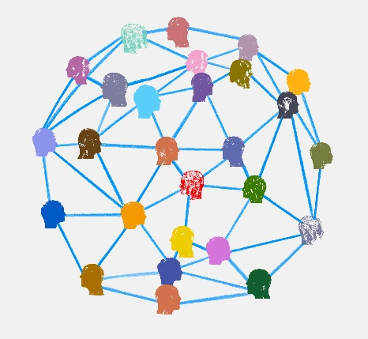

# Our tools:

We are equipped in several ways to fulfil our mission:

* Expert advice to Ofcom, governments, and industry – highlighting opportunity, risk, and detriment
* Respected to facilitate debate
* Robust research and evidence
* Conduit for information

  

# How we work

The communications market is complex, highly technical, fast-moving, and continually evolving - and impacts across society and the economy.

The Panel and ACOD’s work is diverse and broad, covering not only telecommunications such as broadband, spectrum (mobile and TV airwaves) and mobile, but also online safety, post, elements of broadcasting and cross-cutting issues such as digital inclusion.

One of our key aims is to highlight the consumer, citizen and micro-business experience to Ofcom, industry, and governments to help to make communications sector practice and policy-making inclusive.

The Panel has a unique role, as a ‘critical friend’ to Ofcom**.** The Panel’s wide remit enables it to identify projects that are often apparently unrelated but raise similar consumer issues – we can then ensure that connections are made between them.

Our sector specialism, experience and understanding allow us to robustly challenge communications policy development from a position of strength, supported by sound evidence and resulting in pragmatic actions based on real world solutions.

The Panel works to influence before, during and after policy development – through a variety of methods and channels. Our work results in significant policy changes - we contribute expert advice to ensure consumers’ and citizens’ interests are high on the agenda and we do not shrink from airing issues more widely if necessary.

We have based our key priorities on identified issues in the sector, such as those outlined by stakeholders including Ofcom in its draft [Plan of Work](https://www.ofcom.org.uk/__data/assets/pdf_file/0030/273288/ofcoms-plan-of-work-2024-25.pdf) (Annex 1).

We also adopt a flexible approach to our strategic plan – this means that, as the sector evolves, we can continue to ensure that the voices and interests of consumers, citizens and microbusinesses are heard in the communications sector.

The sector presents different challenges to those faced in utilities such as energy and water; in many ways it is closest to financial services in its complexity, vast range of providers and related competitiveness.

Panel Members’ own insights from their work in other sectors, as well as the insights gained from our consumer research and our National Hubs and Consumer Stakeholder Hubs, help us to keep aware of the differences and similarities in consumer experiences across sectors.

# Our stakeholder network and policy input mechanisms

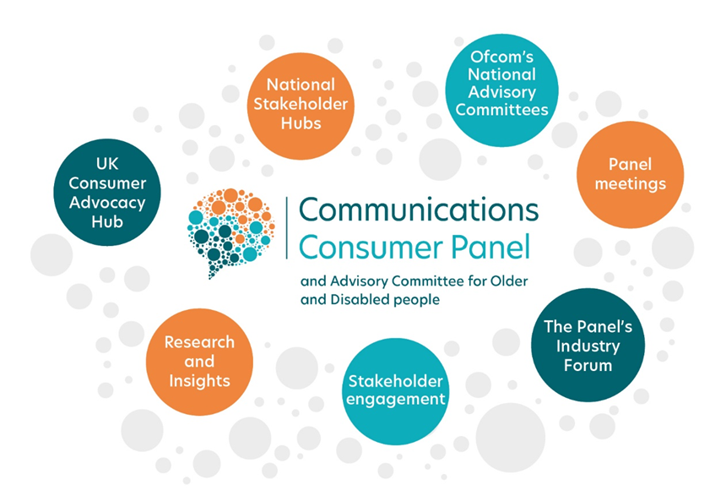

We work closely with our UK-wide consumer stakeholder base to hear their insights on a wider range of issues such as the harm caused by the cost-of-living crisis, debt, and disconnection, to the difficulties of finding a provider that will serve a remote community.

We build these issues into our strategic plan, and ensure we highlight the information to those who could directly make a difference.

We collaborate with other consumer bodies, academics, industry, Ofcom, and governments to ensure the consumer voice reaches communications policymakers and providers.

* + **National Stakeholder Hubs:** we facilitate a vibrant UK-wide network of National Stakeholder Hubs and meet with participants regularly to listen to the cutting-edge issues faced by the consumers, citizens, and micro-businesses they represent, when using the communications sector. These meetings also help us keep aware of useful consumer research taking place in other sectors. We also meet with participants individually in between Hub meetings.
  + **Ofcom’s National Advisory Committees:** our member for each of the UK Nations attends the Ofcom Advisory Committee for that Nation, sharing the CCP-ACOD’s findings and listening as an observer to committee discussions.
  + **Panel meetings:** our monthly meetings give us an opportunity to listen to and advise on Ofcom’s early policy proposals and to ‘connect the dots’ between Ofcom’s projects and our insights from our research and our engagement with stakeholders.

We provide expert advice to industry, Ofcom, and governments, in meetings, consultation responses and via our publications, informing the debate by commissioning robust independent research.

* + **Industry Forum:** we facilitate a ‘safe space’ for the main industry players in the telecoms sector to discuss and debate non-competitive consumer issues. We provide them with presentations from best practice customer service providers in other sectors, with a particular focus on fairness for consumers who may be more susceptible to harm in this sector.
  + **Wide-ranging stakeholder engagement:** we share insights with other consumer bodies, charities, and not-for-profits to expand the public knowledge base on behalf of consumers, citizens, and micro-businesses, extending the value of our research and insight programme.
  + **Research and Insights:** we commission our own consumer research and confer with Ofcom’s Market Research team and our external stakeholders to ensure we commission useful, robust, and insightful studies that will help us to influence policy and practice. We target our research budget carefully, seeking to hear from consumers who may be less heard in the typical design of communications services and less targeted in a competitive market, making them more susceptible to harm. We take the findings of our research to stakeholders and share recommendations for improvements, incorporating what we have learnt from our wider stakeholder engagement.

In the past three years we have published research on a number of consumer, citizen, and micro-business focused issues, from affordability, to choice, to reliability and quality of service, to public safety. All of our completed research reports have been – and will continue to be - published here: [Research and reports - Communications Consumer Panel](https://www.communicationsconsumerpanel.org.uk/research-and-reports-introduction/research-and-reports) ([www.communicationsconsumerpanel.org.uk](http://www.communicationsconsumerpanel.org.uk))   
  
We have looked at the evolving picture of consumer awareness of Migration to VOIP, following recent initiatives by communications providers and others to raise awareness in specified parts of the UK - and we welcomed Consumer Scotland’s insight into the impact on consumers in Scotland.

We have looked into consumers’ awareness and use of social tariffs in this sector, understanding what they expect, need, and understand.   
  
We looked into rural consumers’ and micro-businesses’ experiences of purchasing and using communications and postal services, following up with projects this year that used the same robust methodology and striking videography to delve into the experiences of people living and working in inner cities across the UK – and micro-businesses in both rural and urban settings.

We worked with Ofcom to commission an innovative mixed-methodology study looking at how research can be designed, commissioned, carried out and reported on in a way that is inclusive of disabled people and people with long-term health conditions.  
  
In 2024/25 we plan to focus our research on the impact on consumers of temporary network outages, such as, but not limited to, those experienced in recent years during winter storms – and Alternative Dispute Resolution – taking into account the needs of consumers who have persevered beyond their communications providers’ complaints processes to seek redress or prevent harm to other consumers. We hope to provide insight to Ofcom, governments, and industry, and will continue to share the findings with our consumer stakeholders.

* + **UK Consumer Advocacy Hubs:** we value highly our connections with other UK consumer bodies. Our Consumer Advocacy Hub is invaluable in ensuring that we share issues of mutual interest and complement, rather than duplicate, each other’s work.

We will continue to strengthen and build these key relationships in the coming years.

**The role of consumer panels in regulation**

We believe in learning from best practice in other sectors, so that communications consumers can receive an accessible, trusted, affordable and reliable service, with excellent standards of customer care. We share insights with consumer panels in other sectors, with the thought firmly in mind that no consumer lives solely in one sector.   
  
The CAA’s Consumer Panel has undertaken important work [considering the UN consumer principles in an aviation context](https://www.caa.co.uk/publication/download/18156#:~:text=The%20consumer%20principles%20are%3A%20access,%2C%20sustainability%2C%20privacy%20and%20representation.) (Annex 2), building on previous work by the Legal Services Consumer Panel. We will further this valuable analysis and build stronger cross-sectoral insight by considering the consumer principles in a communications context.

# Key Priorities

# We examined the layers of detriment affecting consumers across all parts of the UK, across a range of circumstances, using insights gathered from our own and our stakeholders’ research and our regular engagement with consumer bodies, charities, and academics, and identified four overarching priorities:

* Connectivity
* Affordability
* Accessibility, and
* Trust and Reliability

**Consumer advocacy: Influence + Facilitation + Evidence = Change**

We will be accountable for delivering against our key priorities. Consumer advocacy is often based on a combination of influence, facilitation, and evidence.   
  
**Specific issues and challenges** **- and overarching themes**

Although we can identify a number of clear examples of where we have been successful, establishing a direct correlation to changes in policy and practice can be difficult. However, we will endeavour to measure how we have effected change in the sector, not least by the activities we have undertaken, the evidence provided, and the advice given.

The table on the next page sets out some specific issues and challenges we expect to face in the next three years, sitting under our identified priorities. Some overarching themes- issues identified as a priority for consumers under more than one of the above headings have been called out in **\*bold*.**

|  |  |
| --- | --- |
| Priority | Specific Issues & Challenges |
| Affordability | * Social tariffs and other affordable tariffs * Bridging the digital divide: Minimum Digital Living Standard (MDLS) and other work across the UK to tackle digital poverty * Handling of debt collection * Effects of market consolidation * Ease of switching * Roaming when abroad and inadvertent domestic roaming * Annual index-linked price increases and awareness * Universal Postal Service Regulation * Future of Universal Postal Service - how do we support the inevitable change in the service – what do older/disabled/rurally based people need? |
| Accessibility | * Supporting and enabling an ageing population * Rural and remote service access* * Inclusive design and relevant models of disability – Social Model and beyond * How do we help the industry to reach underserved groups? * Polarisation of opportunity * Equality of outcome * Improving CPs’ response to consumers who don’t fit into neat classifications and have additional needs/requirements. * How do we get to a consistent understanding from CPs on how and what to record. * How to encourage the use of the social model of disability. * Is an industry Charter required? * Work with Ofcom to improve understanding of long-term health conditions and disabilities. * Should Royal Mail have a Priority Service/Fault Register? |
| Connectivity | * Universal access across the UK * Alt-net viability * Urban detriment * Geo-politics * Infrastructure threats * Rural and remote connectivity * Impact of a delayed Shared Rural Network * 2G/3G switch-off * Access to emergency and health monitoring services * Future of Universal Postal Service - how do we support the inevitable change in the service – what do older/disabled/rurally based people need? |
| Quality of service | * Universal Postal Service - how do we support the inevitable change in the service – what do older/disabled/rurally based people need? * What's the current reality of consumer experience especially for consumers at greater risk of detriment and for when things go wrong? * Is customer experience improving, or are there signs that the operational pressure on CPs is resulting in a more 'averaged' approach * Marginalisation of consumers as the industry seeks greater efficiency * Explore the design of a consumer duty in telecoms * Complaint-handling and Alternative Dispute Resolution |
| Trust and Reliability | * Communication with consumers around widescale industry changes (e.g., Migration to Voice-over IP: how do we evidence the need for greater awareness of transition and what this will mean?) * Network Resilience - what more should the regulator and CPs be doing to minimise the risk of network 'outages' and ensuring support to consumers most susceptible to harm when this happens? * As providers’ networks and communications services are increasingly inter-connected, what should consumers expect of the market/regulator to safeguard these services better in the future, given that they are now so essential? * Premium rate services: transfer of responsibilities back to Ofcom * Immersive technologies (including virtual reality (VR) and augmented reality (AR)) and connected devices (such as autonomous vehicles or drone technology) are likely to grow to play a bigger role. These all may benefit society while also exacerbating the risk of harm. * Prevention and protection from scams and fraudulent activity * Alt-net viability * Universal Postal Service: focus on ensuring consumers and citizens most at risk of detriment and who rely on post are going to sufficiently protected in any new regime, and bringing practical examples of the potential harm a more relaxed regime might cause. * Online Safety is a regime focussed on the systems and processes of the companies running search and social media services. Ofcom is required to ensure companies are meeting duties of care for UK users of user-to-user and search services - define the consumer and citizen interest and develop an approach to where Panel can impact. |
| Unknown | * There may be consumer, citizen, and micro-business concerns that we are as yet unaware of. * We will continue to listen to stakeholders, build new connections and seek input. Please contact us at [contact@communicationsconsumerpanel.org.uk](mailto:contact@communicationsconsumerpanel.org.uk) if you would like to discuss anything in this report, or raise our awareness of something you believe we should focus on in the next three years, in the UK’s communications sector, that creates risks or opportunities for consumers, citizens and, or, micro-businesses. |

# 

# Annex 1

**Ofcom 2024/25 Plan of Work**

Ofcom’s 2024/25 Plan of Work focuses on four enduring priority outcomes: ‘Internet we can rely on’, ‘Media we trust and value’, ‘We live a safer life online’ and ‘Enabling wireless services in the wider economy’. 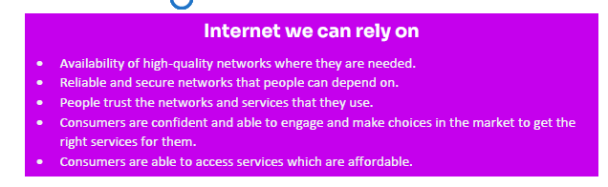

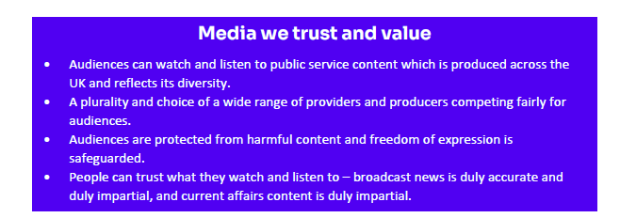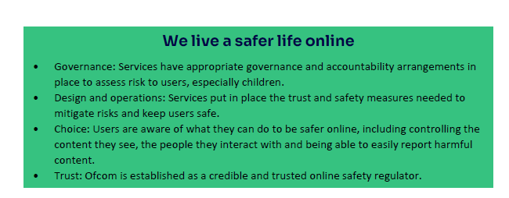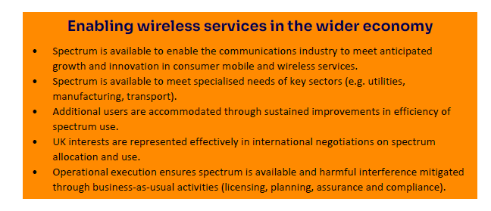

In addition to the above four outcomes, Ofcom intends to continue its work on regulating the postal sector, examining the future of the Universal Service Obligation (USO), and assessing Royal Mail’s quality of service performance during 2023/24.

# Annex 2

**The Consumer Principles and UN Consumer Guidelines**

A straightforward way for regulators to think about the consumer interest in a structured manner is to use the consumer principles. The principles were first set out by President Kennedy in a speech to the US Congress in 1962 and later expanded on by the international consumer movement.   
  
The principles are well-established and are still commonly used by consumer organisations[1] to work out how particular issues or policies are likely to affect consumers. They can help to identify key subjects and questions that need to be investigated further and provide a consistent framework for approaching issues.  
  
The consumer principles are **access, choice, information, education, safety and quality,** **protection of economic interests, fairness and equity, redress, sustainability, privacy, and representation.**

A similar list, expressed as rights rather than principles, form part of the United Nations Guidelines for Consumer Protection.[2]

**Case study: using the Consumer Principles in the context of aviation.**

One of the CAA’s purposes is to support consumers in relation to **choice**, **value** and **fair treatment**.

The consumer principles can help provide a framework to enable this.

**Access**

Consumers should be able to access services at a price and quality that suits their needs. Barriers to access should be identified and addressed. Barriers could include price or difficulty finding relevant information for example.

**Choice**

Where consumers have choice, they should be able to affect the way goods and services are provided through the choices they make in the marketplace. In order to exercise choice consumers, need to be able to find meaningful information, at the right time, and in a format that makes it easy to compare. To be able to exercise choice confidently consumers also need a strong regulatory framework to protect them if things go wrong.

**Information**

Consumers need clear, comparable, and timely information to be able to make decisions. Conversely, having too much information, or information that is too complex or difficult to compare, can impede decision making and lead to poor consumer choices. More information is not always the best policy response, and regulators should test information remedies to assess whether or not they work effectively in the consumer interest. Information can also be used by regulators and third parties to drive up standards.

**Safety and quality**

Consumers should have access to safe and high-quality services that meet acceptable standards. Where a business is regulated, it is important that consumers have confidence in safety, that quality is effectively monitored and there are mechanisms in place to address poor performance.

**Protection of economic interests**

Consumers should be able to access clear information when purchasing goods and services so that they can be protected from risk and make effective decisions which enable them to obtain value for money.

**Fairness and Equity**

Whilst the principle of access is covered above, there is a further expectation that consumers will be treated fairly and equitably by providers. Many sector regulators have explicit requirements (for example through licensing regimes) that consumers should be treated fairly, and in most sectors alternative dispute resolution will also take into consideration what is fair and reasonable in all the circumstances. Regarding equity, regulators should ask themselves whether some, or all, consumers are unfairly discriminated against.

**Redress**

Without redress consumers cannot enforce their rights and there is less incentive for businesses to follow the rules. This can lead to undesirable outcomes including weakened competition, unscrupulous businesses gaining an unfair advantage, and loss of consumer trust in a market.

To help overcome this it is important that consumers have access to a simple, cheap, quick, and fair system for dealing with complaints and disputes if things go wrong.

**Sustainability**

The promotion of sustainable consumption patterns to protect the environment and meet wider sustainable development goals. Consumers need to be provided with reliable and trustworthy information and education about services to enable them to make effective choices.

**Privacy**

The protection of consumer privacy should be considered when developing services. Consumers need to be able to trust organisations to respect the privacy of data provided when purchasing goods and services.

**Representation**

The views, experiences and expectations of consumers should be taken into account in service design and provision, and the process of decision-making should be transparent.

Businesses need to understand this to provide effective services, while regulators need to understand it to design effective protections. Consumers are not one homogenous group and work should be undertaken to segment consumer groups and reach a rounded understanding of consumer needs and preferences. It is also important to consult specialist representative bodies.

**Education**

Consumers today operate in increasingly complex markets, with ever greater amounts of information and choice of products and services. Consumer education is critical in this regard. It can be defined as a process of developing and enhancing skills and knowledge to make informed and well-reasoned choices that take societal values and objectives into account.[3] Consumer education can also help build the confidence consumers need to operate in complex markets.

1. This paper is based on a paper published by the Legal Services Consumer Panel: Legal Services Consumer Panel, *The Consumer Interest*, January 2014.
2. [https://unctad.org/system/files/official-document/ditccplpmisc2016d1_en.pdf.](https://unctad.org/system/files/official-document/ditccplpmisc2016d1_en.pdf) See also Consumers International, the Consumer Principles: [https://www.consumersinternational.org/media/2049/un-consumer-protection-](https://www.consumersinternational.org/media/2049/un-consumer-protection-guidelines-english.pdf) [guidelines-english.pdf.](https://www.consumersinternational.org/media/2049/un-consumer-protection-guidelines-english.pdf)
3. See for example [https://www.oecd.org/sti/consumer/44110333.pdf.](https://www.oecd.org/sti/consumer/44110333.pdf)